**Manual Document**

**We used Eclipse IDE to make the application. You can on GUI.java and click the run button as seen below. We can use File transfer systems, or Git or other online systems to share our code. Later to run the code Go to File -> Import by browsing into your directory.**

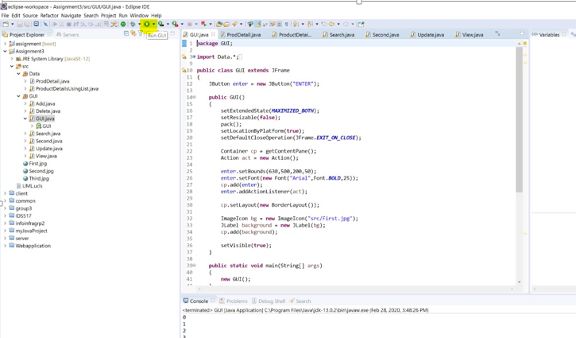

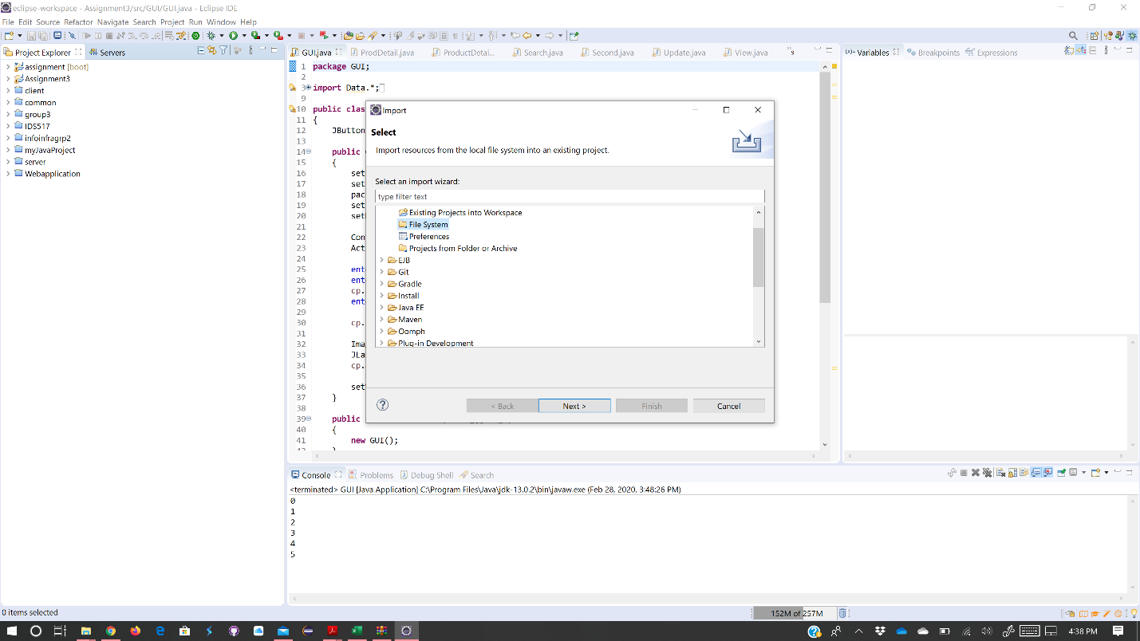

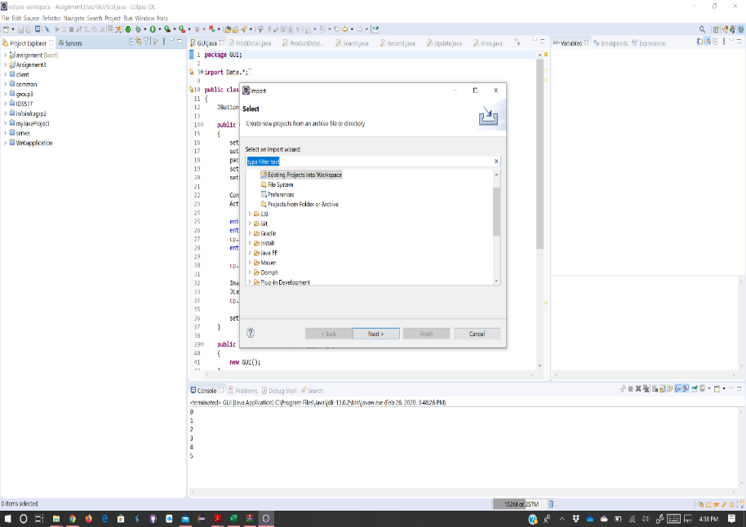

You can see our inventory management system as seen below. Please press enter to continue.

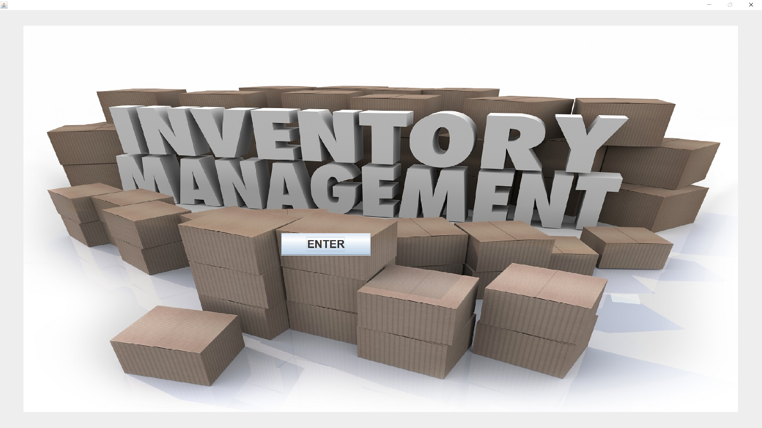

You can see the Main Menu display as seen below

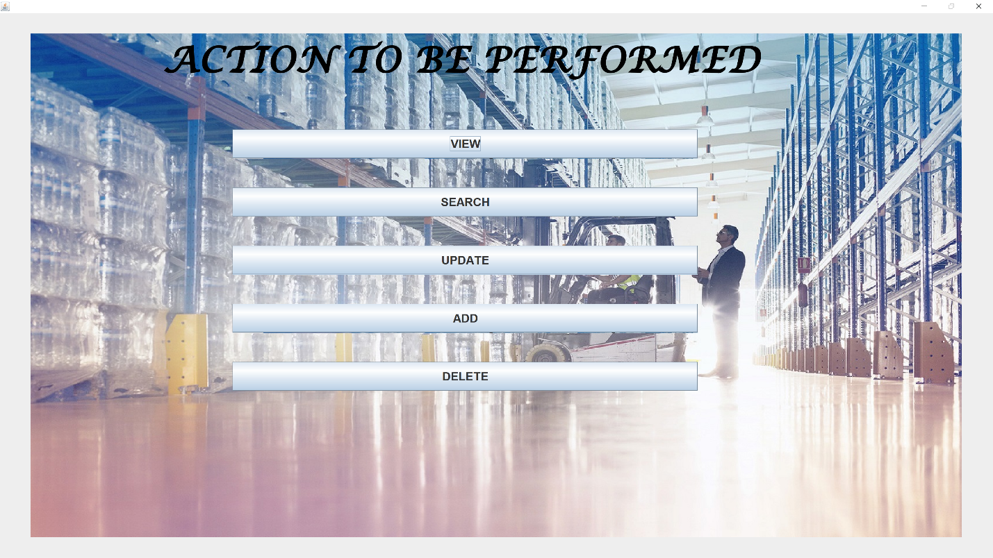

Now you have the following option

* VIEW
* SEARCH
* UPDATE
* DELETE
* ADD

1. View – You can view the entire inventory and also sort using the following options

* Product ID
* Product cost
* Manufacturer
* Product

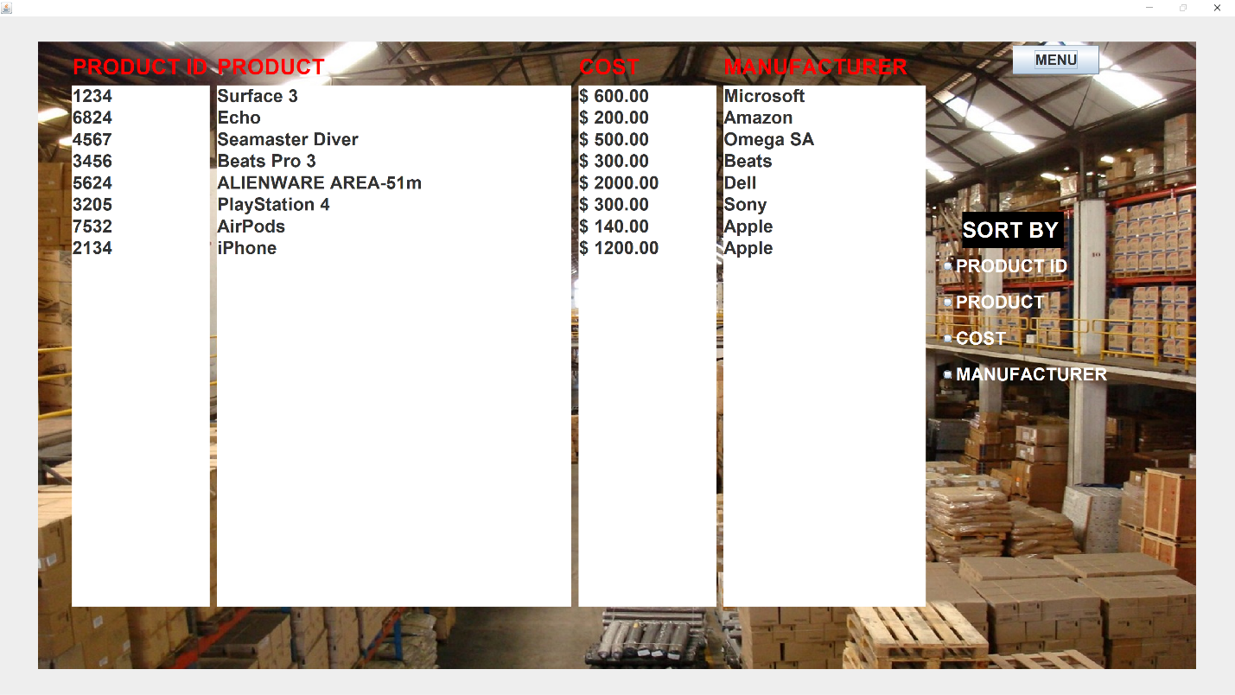

1. Search - drop down box. Search based on whatever category

You can search the entire inventory and also sort using the following options

* Product ID
* Product cost
* Manufacturer
* Product

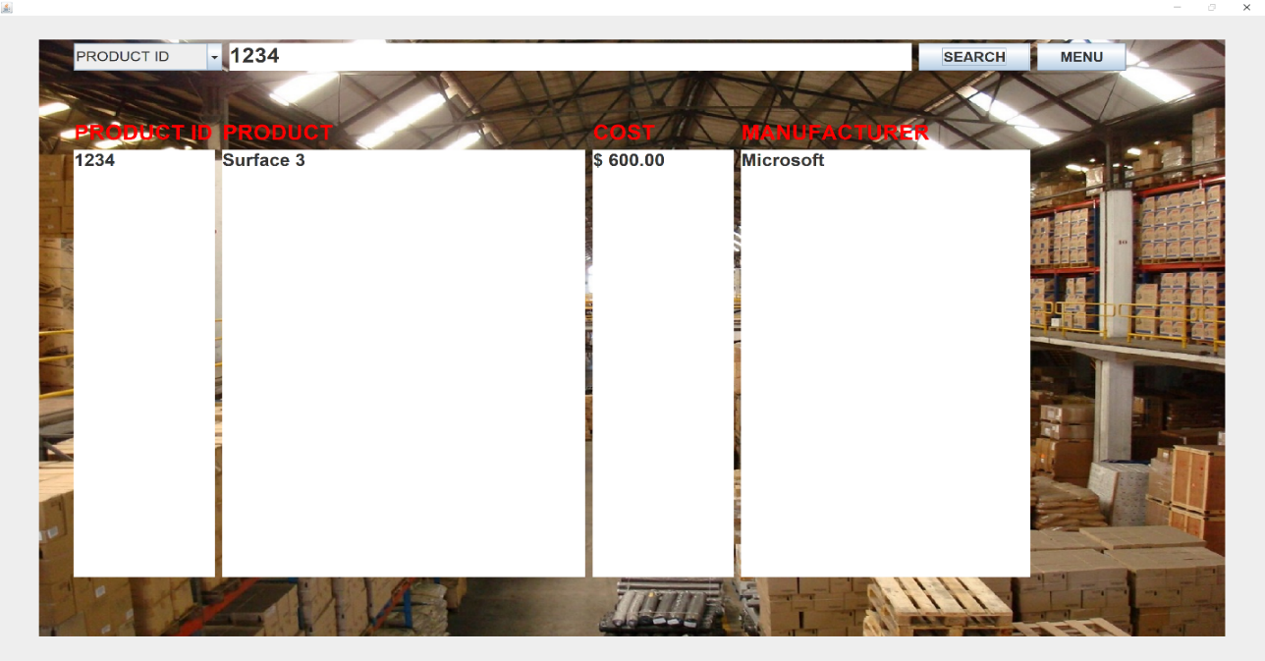

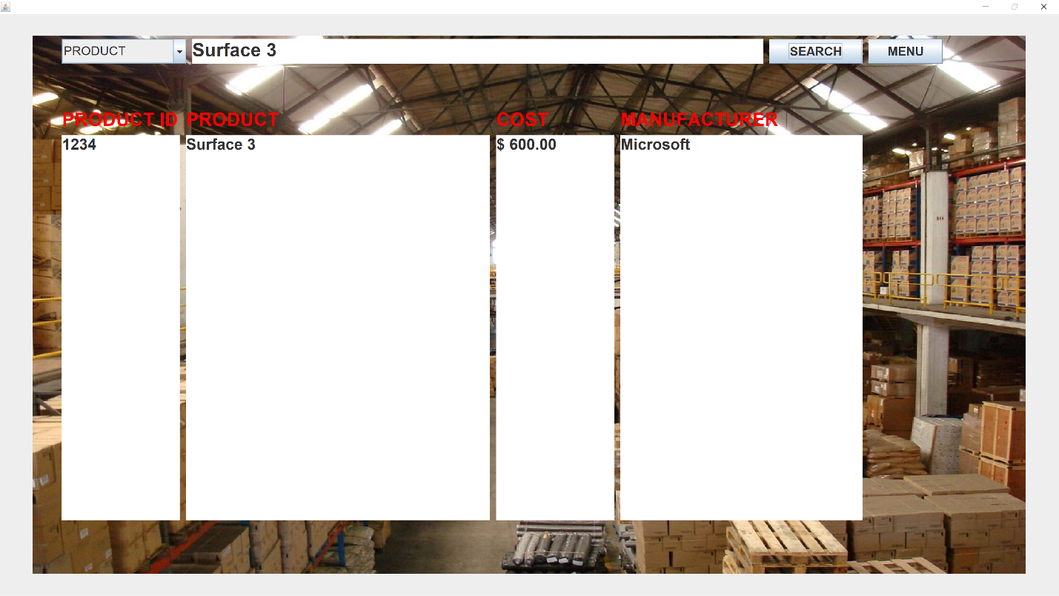

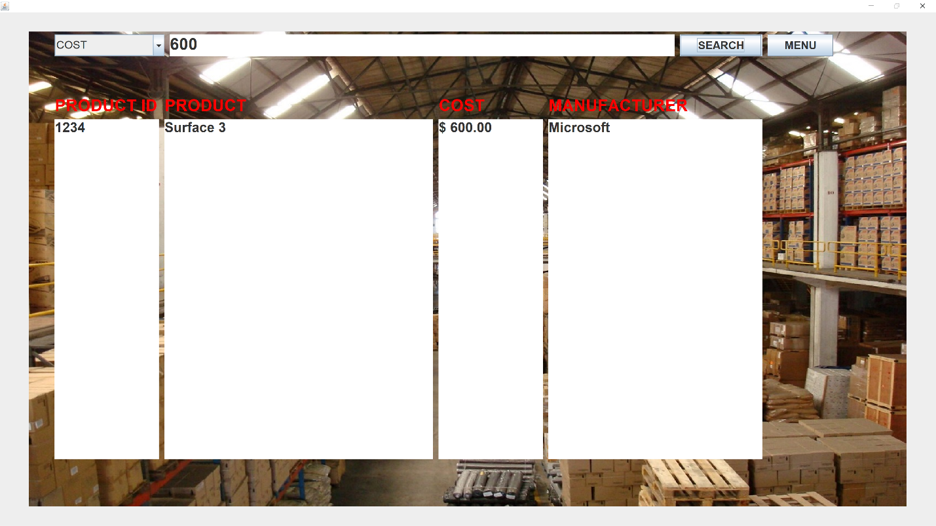

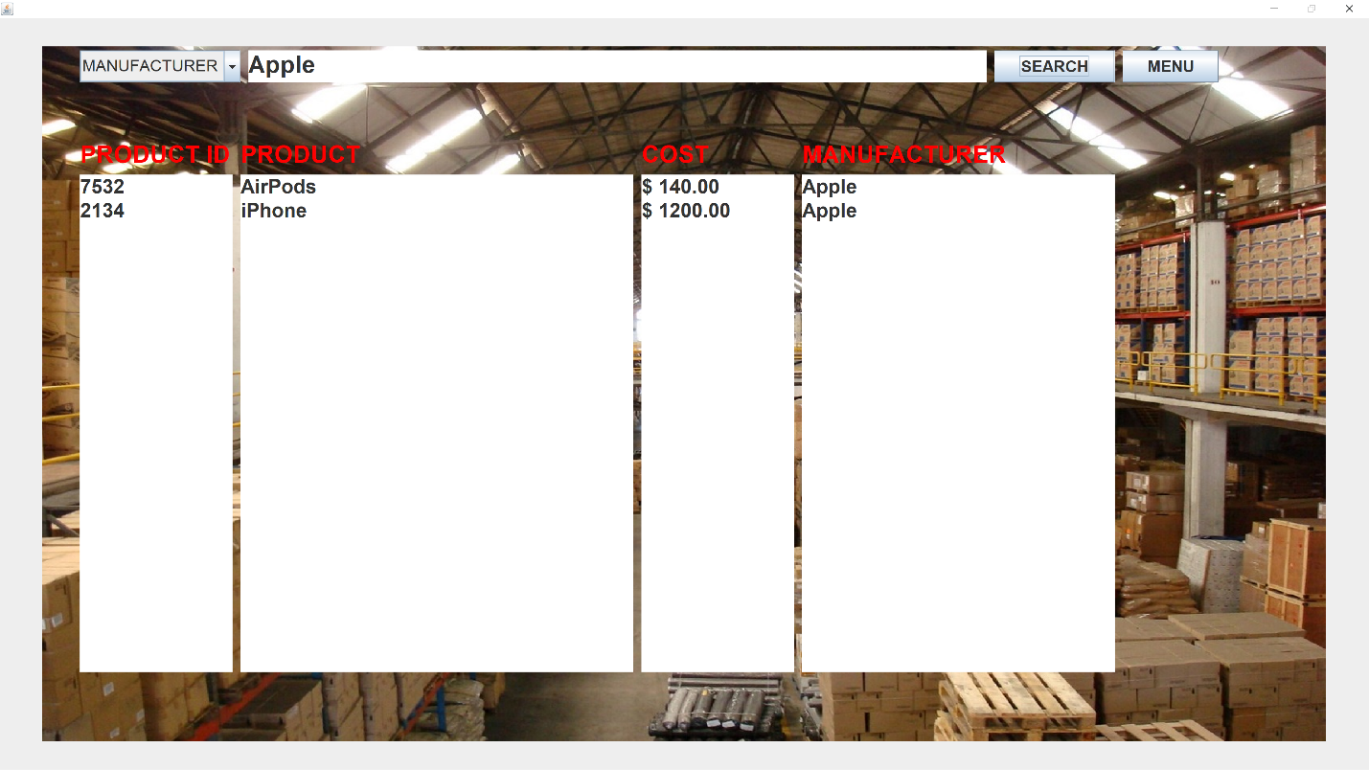

1. Update & Delete - search prod with prod Id. You can update or delete.

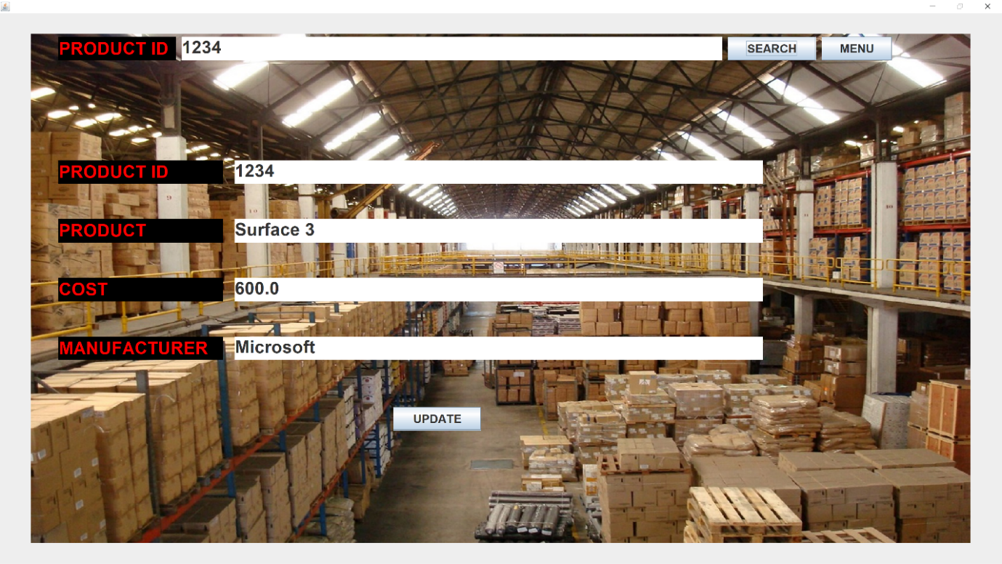



Delete

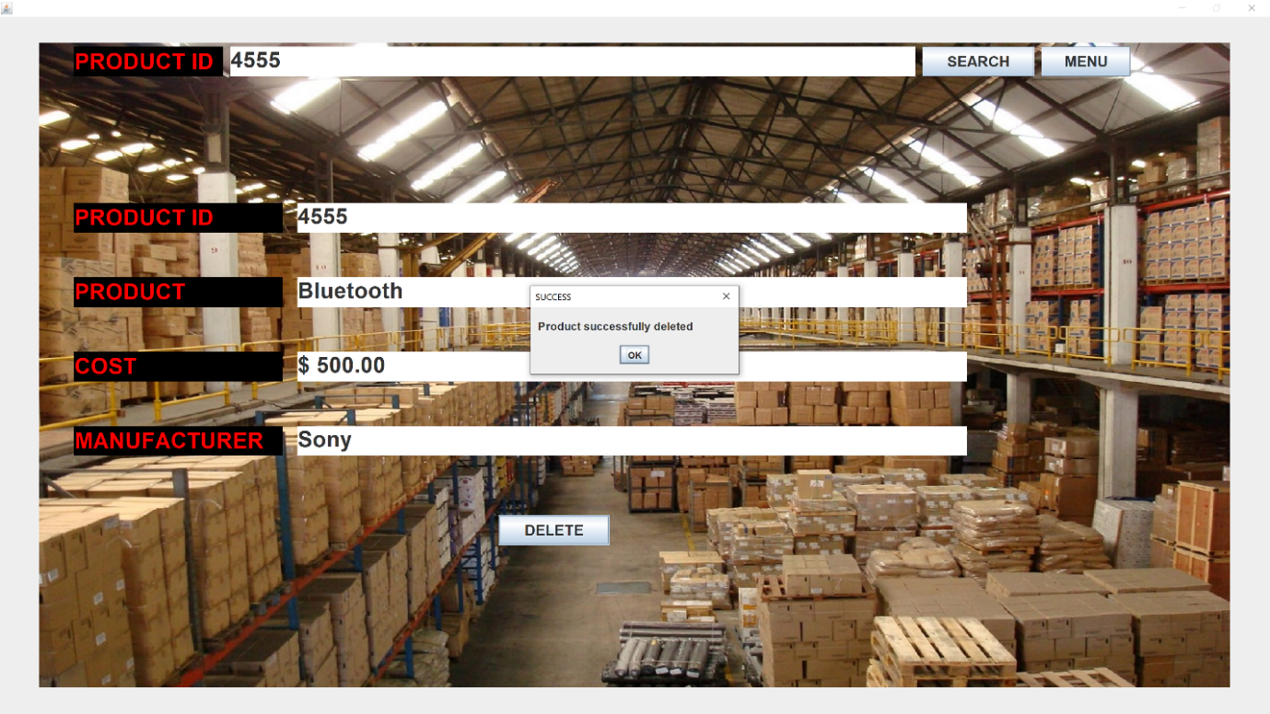

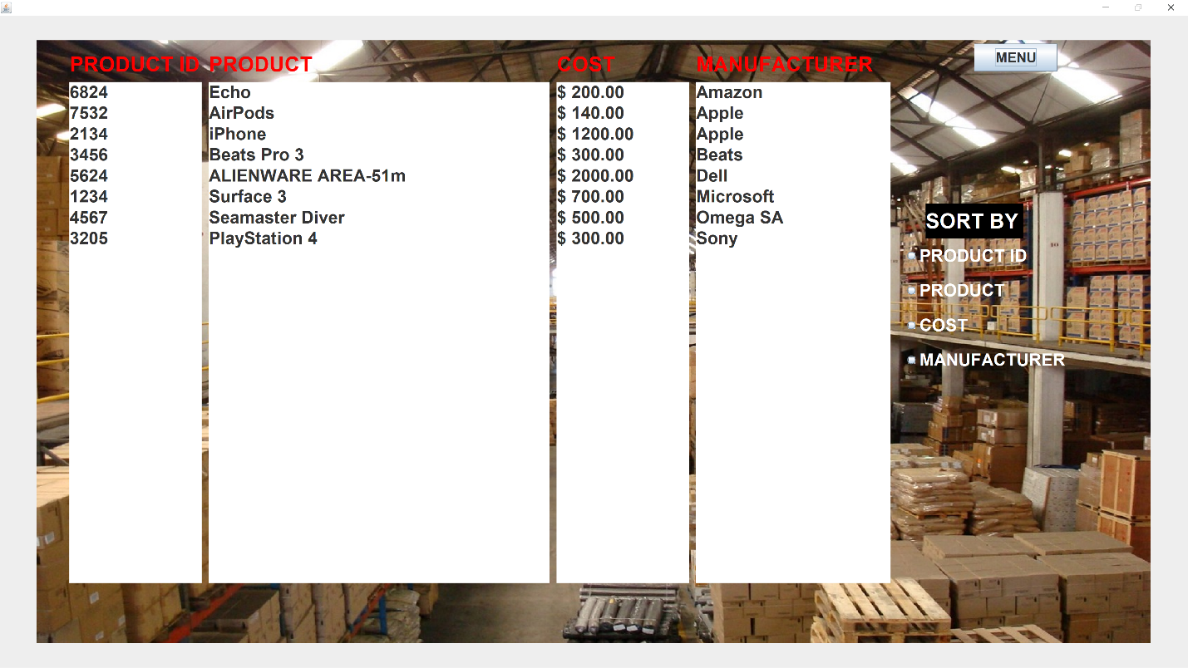

1. Add - add new item and details

